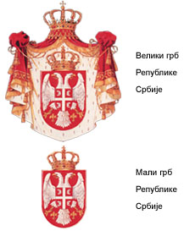
Republic of Serbia
GOVERNMENT OF THE
REPUBLIC OF SERBIA
ANTI-CORRUPTION COUNCIL
72 No: 07-8122/2007
20 August 2007
B e l g r a d e

THE GOVERNMENT OF THE REPUBLIC OF SERBIA
- Prime Minister Vojislav Kostunica -

B e l g r a d e

Dear Sir,

The Anti-Corruption Council has received a number of complaints with comprehensive documentation related to the takeover of “C-market” a.d. in 2005 with claims about illegal agreements concerning the takeover of the shares from small shareholders of this enterprise between the potential buyers “Delta M” and “Laderna B.P.” and the Director of “C-market”, on the initiative of the Prime Minister of the Republic of Serbia, and in the organization of Mr. Danko Djunic. Enclosed are the complaints received by the Council, as well as a Memorandum of Understanding, signed between the mentioned parties. The persons who sent the complaints claim that the signing of the Memorandum caused the other tenderers to withdraw from participating in the Tender, and after that, 77% of the “C-market” shares were bought by the Memorandum signatories at a previously-fixed price, allegedly four times lower than the estimated value.

As the Anti-Corruption Council is preparing a report on the takeover of “C-market”, please inform us whether the documentation we have received is authentic or not.

Yours faithfully,

COUNCIL PRESIDENT

Verica Barac

